Cookie

🍪 What Is a Cookie in Web Development?
# Source: AI Source: Provided by: [Data Path: Persons Table -> ID Column: 1, Name_En Column: Motasem Essam] -> From: [ChatGPT] on [2/12/2026]
A cookie is a small piece of data stored on the user’s browser by a website.
It helps the site remember information across different pages or visits — like whether you're logged in, your preferences, or what's in your cart.

✅ Simple Definition:
# Source: AI Source: Provided by: [Data Path: Persons Table -> ID Column: 1, Name_En Column: Motasem Essam] -> From: [ChatGPT] on [2/12/2026]
A cookie is like a tiny notepad that your browser saves for each website to help it remember who you are.

🧠 Real-Life Analogy:
# Source: AI Source: Provided by: [Data Path: Persons Table -> ID Column: 1, Name_En Column: Motasem Essam] -> From: [ChatGPT] on [2/12/2026]
Think of a cookie like a ticket stub:
- You get it when you enter (visit the site)
- You show it every time you come back (so the site remembers you)
- It has info like your name or seat number (user ID, settings)

🔁 How Cookies Work:
# Source: AI Source: Provided by: [Data Path: Persons Table -> ID Column: 1, Name_En Column: Motasem Essam] -> From: [ChatGPT] on [2/12/2026]
- 🧑‍💻 You visit a website → the server sends a cookie
- 🍪 Your browser saves it locally
- 🌐 On every visit to the same site, your browser automatically sends that cookie back to the server

📦 What Cookies Can Store:
# Source: AI Source: Provided by: [Data Path: Persons Table -> ID Column: 1, Name_En Column: Motasem Essam] -> From: [ChatGPT] on [2/12/2026]
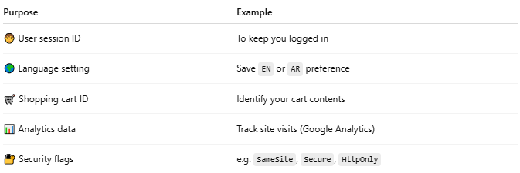

Purpose | Example
🧑 User session ID | To keep you logged in
🌍 Language setting | Save EN or AR preference
🛒 Shopping cart ID | Identify your cart contents
📊 Analytics data | Track site visits (Google Analytics)
🔐 Security flags | e.g. SameSite, Secure, HttpOnly

🧾 Cookie Example (Set by Server):
# Source: AI Source: Provided by: [Data Path: Persons Table -> ID Column: 1, Name_En Column: Motasem Essam] -> From: [ChatGPT] on [2/12/2026]
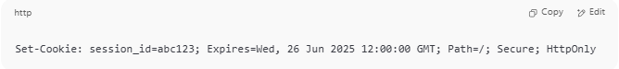

Set-Cookie: session_id=abc123; Expires=Wed, 26 Jun 2025 12:00:00 GMT; Path=/; Secure; HttpOnly

💻 In PHP: Set and Read Cookies
# Source: AI Source: Provided by: [Data Path: Persons Table -> ID Column: 1, Name_En Column: Motasem Essam] -> From: [ChatGPT] on [2/12/2026]
Set a cookie:
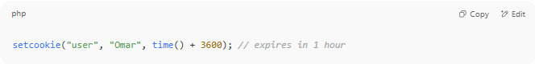
setcookie("user", "Omar", time() + 3600); // expires in 1 hour

Read a cookie:
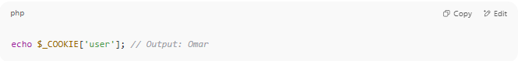
echo $_COOKIE['user']; // Output: Omar

🔐 Cookie Options
# Source: AI Source: Provided by: [Data Path: Persons Table -> ID Column: 1, Name_En Column: Motasem Essam] -> From: [ChatGPT] on [2/12/2026]
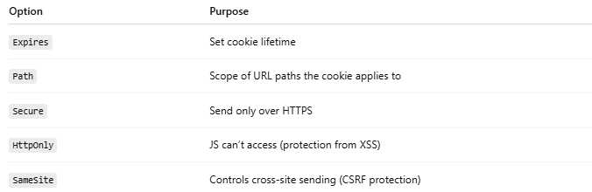

Option | Purpose
Expires | Set cookie lifetime
Path | Scope of URL paths the cookie applies to
Secure | Send only over HTTPS
HttpOnly | JS can’t access (protection from XSS)
SameSite | Controls cross-site sending (CSRF protection)

🧯 Cookie vs Session vs Token
# Source: AI Source: Provided by: [Data Path: Persons Table -> ID Column: 1, Name_En Column: Motasem Essam] -> From: [ChatGPT] on [2/12/2026]
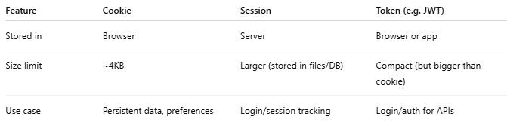

Feature | Cookie | Session | Token (e.g. JWT)
Stored in | Browser | Server | Browser or app
Size limit | ~4KB | Larger (stored in files/DB) | Compact (but bigger than cookie)
Use case | Persistent data, preferences | Login/session tracking | Login/auth for APIs

⚠️ Security Tips
# Source: AI Source: Provided by: [Data Path: Persons Table -> ID Column: 1, Name_En Column: Motasem Essam] -> From: [ChatGPT] on [2/12/2026]
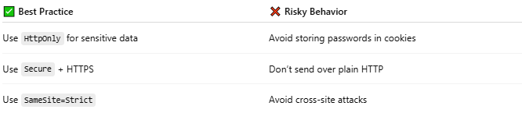

✅ Best Practice | ❌ Risky Behavior
Use HttpOnly for sensitive data | Avoid storing passwords in cookies
Use Secure + HTTPS | Don’t send over plain HTTP
Use SameSite=Strict | Avoid cross-site attacks

